PROJECT: GBMES

ACCEPTANCE TEST procedure

FOR

ACCE RUGGED KEYBOARD WITH TRACKER BALL

BEL Part No: 4461 722 602 31

(Designed by BEL – Hyderabad)

Prepared By
BEL-Hyderabad
Checked By
BEL QC - Hyderabad

Approved By
DGAQA

The Document is supplied on the express terms that it is to be treated as confidential and that it may not be copied, used or disclosed to others for any purpose except as authorized by Bharat Electronics, Hyderabad.
Bharat Electronics
Industrial Estate, Nacharam,
Hyderabad -500076,
Telangana,
INDIA.  Telephone: | 040 27194208
Fax: | 040 27151243

ISS | PAGE NO. | CP NO. | DATE | CHANGE | APPROVED BY
P1 |  |  | 04.10.16 | ORIGINAL

THIS IS AN ELECTRONICALLY APPROVED DOCUMENT, HENCE DOES NOT REQUIRE SIGNATURE

This document describes the procedure for carrying out ACCEPTANCE Tests on ACCE RUGGED KEYBOARD WITH TRACKER BALL

THIS IS AN ELECTRONICALLY APPROVED DOCUMENT, HENCE DOES NOT REQUIRE SIGNATURE

CONTENTS

SL.NO. | DESCRIPTION | PAGE NO.
1 | Introduction | 5
1.2 | Reference Documents | 7
2.0 | Test Equipment Required | 7
3.0 | Physical Inspection | 7
4.0 | Functional Test Procedure | 8
5.0 | Defect /Failure Analysis | 16
6 | Test Data Records | 17
7 | Defect Investigation Report | 19

1.0 INTRODUCTION:
This document outlines the procedure for conducting ACCEPTANCE tests for the ACCE RUGGED KEYBOARD WITH TRACKER BALL which is part of LCD DISPLAY WITH KEYBOARD & TRACKBALL of GBMES system.
This item is listed under Sl .No.15 of Manufacturer’s Recommended List of Spares
(MRLS) in the contract for GBMES systems. Under this item ttwo components are being supplied , the rugged Keyboard and a rugged tracker ball.
This item is being supplied by M/s Datasol Pvt Limited, Bangalore.

1.1. Brief Description:
Keyboard SLP: 88 keys with 10-key numeric pad green backlighting keys integrated trackball. It is built into a rugged ABS polycarbonate case. The SLP-88 is completely sealed and designed to meet NEMA 4X specifications. It features green LED back-lighting for use in low-light environments,

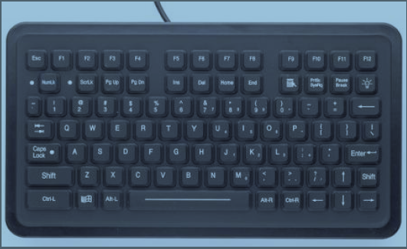

Fig-1: Image of SLP-88 Key Board

Trackball: Designed to replace a standard mouse, the small footprint EC series Tracker ball offers excellent precision cursor control and durability. The tracker ball is designed to give total reliability throughout the entire range of harsh industrial and commercial environments. The EC tracker ball is available with front sealing against water and dust ingress up to IP65 (NEMA 4) standards.

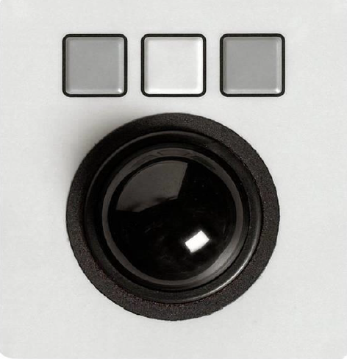

Fig-2: Image of Track Ball

1.2 REFERENCE DOCUMENTS
1.2.1 QTP Document Ref: QTP for p/no. 4461 722 602 31 ver P1 , dtd 10.06.16
1.2.2 ESS Tests: COC from OEM.
1.2.3 MDI/BOM Part no: Not applicable.
1.2.4 BEL PO No.. BEPO / HD4 / 4000057921 dated 05.04.2016
1.2.5 Approved Specifications are as per BEL PP drawing.
1.2.6 Contract No. AIR HQ/S/96135/69/1/ASR Dated 31/07/2015.
1.2.7 SOFTWARE CERTIFICATION - Not applicable
1.2.8 FAILURE ANALYSIS - Refer Appendix-A
1.2.9 MTBF Value of the Sub Assy: Ref BEL letter no. 4706/07/12 dtd 19th Aug 2016 to AHQ.
1.2.10 Packing Drawing No: 9672 001 083 86
1.2.11 Delivery Set List: Enclosed at Annexure B.

2.0 TEST EQUIPMENT REQUIRED:

2.1 CPU of a standard PC with KVM Display or a monitor - 1 No. (Straight)
With the following
2.2 Power cables - 2 Nos.
2.3 Video cable - 1 No.
2.4 Keyboard test tool software

3.0 PHYSICAL INSPECTION:

3.1 Visual:
1.Check the Keyaboard and Track Ball for any damages.
2.Note down the result in TDR-1.
3.2 Dimensions & Drawing Verification:
Physical inspection of the unit is to be carried out wrt dimensions, mounting and other details as per drawing and note down the measured dimensions in TDR-1.
Dimensions :
The following are the dimensions in mm of the parts:
- Functional Keyboard : 172.5(H) X 299.7 (W) X 34.3 (D: max).
- Track Ball : 58 (H)x 78 (W) x 36.17 (D)
Weight :
a) Keyboard : < 0.76 Kgs
b) Tracker ball : 0.25 Kgs(approx)
4.0 Functional Test Procedure:

kEYBOARD & Track ball:
- After switching ON the power to KVM & PC check the system gets booted and display seen on the screen of KVM.
- Install the key board test tool software.

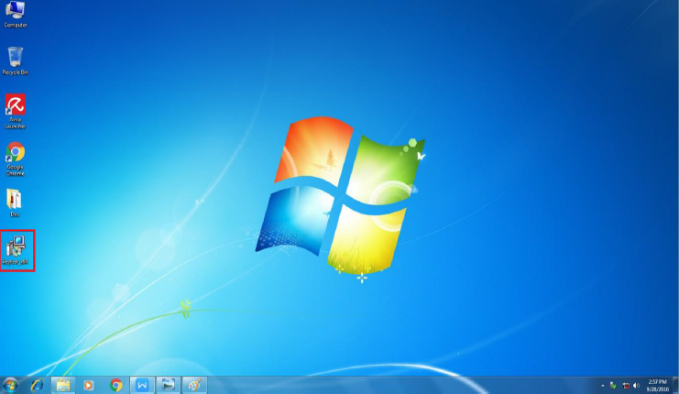

3. Open the key board test tool software.

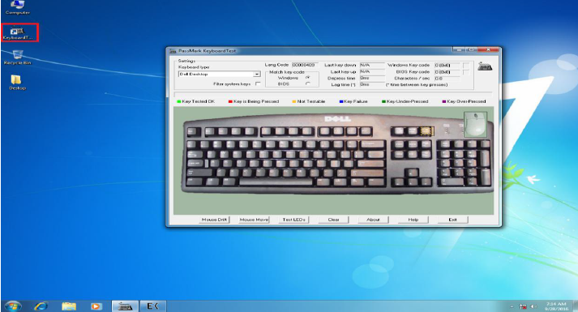

4. Select the Key board layout.
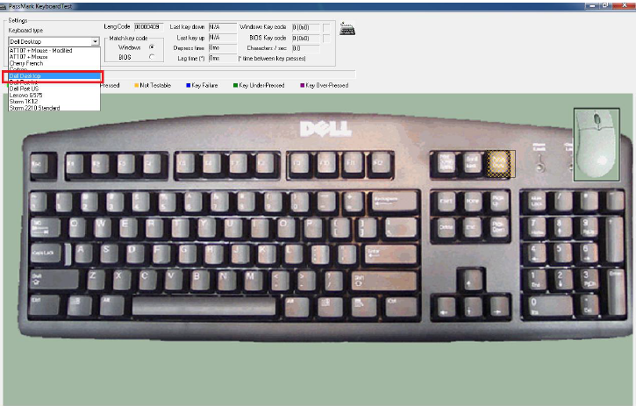
5. Press the all the keys. While pressing the keys it will show the key status and Green color indication. Record the results in TDR-2
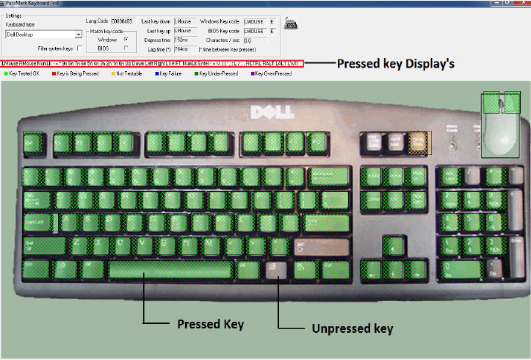

6. Click the left and right .While pressing the keys it will show the key status and Green color indication.
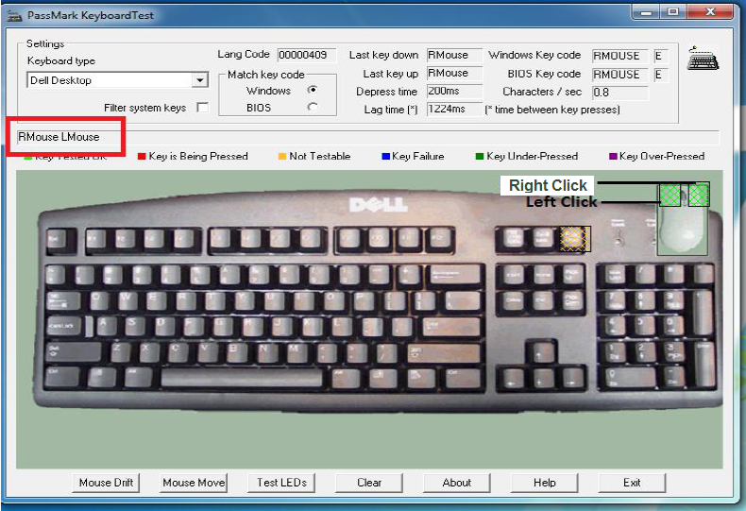

7. To check the Track Ball movement select Mouse move option.
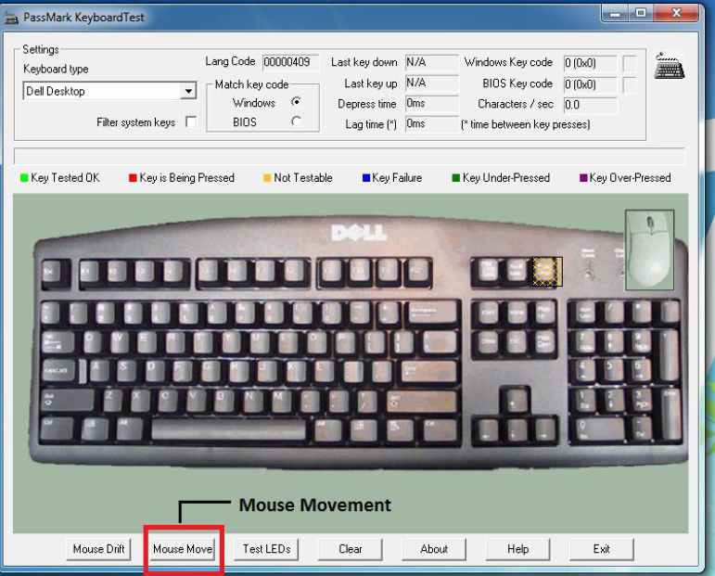

8. Move the Track Ball Each corner of the screen.
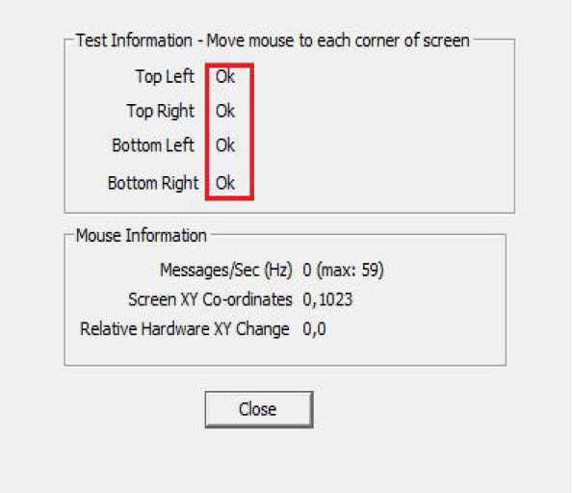

9. To check the Mouse drift select mouse drift option.
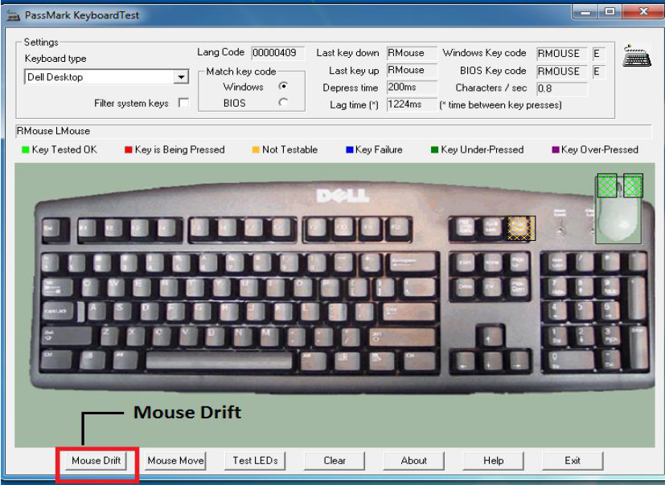

10. Click the start button. It will Check the unwanted drift, once start the test don’t move the Track ball. After 10 Seconds it will show the test status. Record the results in TDR-2.

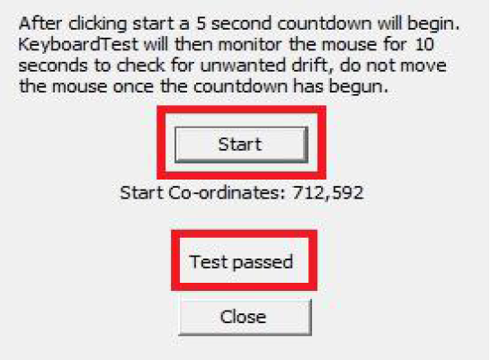

ENVTRONMENTAL STRESS SCREENING (ESS):

As the items are off the shelf items, ESS shall not be done on these.

Visual/Physical Test

Electrical Test

Flow Chart for ATP

6.0 Defect / Failure Analysis: Defect/failure investigation is to be done, entered in the format mentioned in Appendix-A for any failure during any of the tests and filed with the results.

TEST DATA RECORD-1

Sl.no. Date:
Test condition:

1. Physical Inspection:
S.No | Test | Requirement | Result
1 | KVM damages check | No damages | OK /NOT OK
2 | Track Ball | No damages | OK /NOT OK

2. Dimensional Check:
(I) for KEYBOARD
S.No | Description | Specified Dimensions(mm) | Measured  Dimensions(mm) | Result
1 | Width | 299.7 |  | OK /NOT OK
2 | Height | 172.5 |  | OK /NOT OK
3 | Depth | 34.3 |  | OK /NOT OK
4 | Weight | < 0.76 Kg |  | OK /NOT OK

(I) for TRACKER BALL
S.No | Description | Specified Dimensions(mm) | Measured  Dimensions(mm) | Result
1 | Width | 78 |  | OK /NOT OK
2 | Height | 58 |  | OK /NOT OK
3 | Depth | 36.17 |  | OK /NOT OK
4 | Weight | 0.25 Kg |  | OK /NOT OK

RESULT : OK / NOT OK

OEM .Rep BEL-QA.Rep DGAQA Rep

TEST DATA RECORD-2

Sl.no. Date:
Test condition:

FUNCTIONAL TEST:
S.No | TEST | REQUIREMENT | RESULT
1 | Functionality of Keyboard and Track Ball:  Functionality of the keyboard by typing &Tack ball by right clicking / scrolling the ball. | Test by pressing the keys at keyboad & check the same is display on the screen at KVM.  Right click on Track Ball& also by moving cursor to check the mouse is working fine. | OK / NOT OK

RESULT : OK / NOT OK

OEM .Rep BEL-QA.Rep DGAQA Rep

Appendix A

DIR  Defect  Investigation  Report | Unit Description:  Unit Sl. No.:
DI NO. | TYPE OF MODIFICATION
DATE: | H/W | S/W N/A |  | BOTH N/A
S/W VERSION: N/A |  |  | CHECK SUM:
PROBLEM REPORTED DURING:

PROBLEM DESCRIPTION:

MODULE / COMPONENT AFFECTED:

DEFECT ANALYSIS & CAUSE OF PROBLEM:

REPAIR / REMEDIAL ACTION:

FOLLOW UP ACTION:

OEM .Rep BEL Design Rep BEL-QA.Rep DGAQA Rep

